DRC and DSC Agenda
EL PASO – TELLER COUNTY 9-1-1 AUTHORITY
DATE: 05.28.2025 @ 10:00
✔ Dispatch Review Committee | ✘ Dispatch Steering Committee
Attendees:

- Approval of Minutes
  - Approval of the 03.26.25 meeting minutes
    - Motion: (Insert Name)
    - Second: (Insert Name)
- Dispatch Review Committee Items
  - Everbridge Questions- Jianna West
  - PFC- Dawn Lucero FTC for Suicidal CC
  - Travel Policy- Renee Henshaw
  - CommsCoach Update- Renee Henshaw
  - Upcoming Classes
  - ProQA Updates and Protocol 41- Joscelyn Niski
  - Q2 Telecommunicator Voting- Joscelyn Niski
    - Reminder of dates
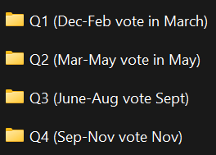

- Dispatch Steering Committee Items
- Round Table
- Motion to Adjourn: (Insert Name)
    - Second: (Insert Name)

